KWAME NKRUMAH UNIVERSITY OF SCIENCE AND TECHNOLOGY

COLLEGE OF ENGINEERING

DEPARTMENT OF ELECTRONIC/ELECTRICAL ENGINEERING



MICROPROCESSOR DESIGN PROJECT

MICROPROCESSORS (COE 381)

GROUP 13

1. Emmanuel Kyeremeh - 8240519
2. Richard Ampofo - 8228919
3. Benecentia Mafo-Kwofie - 8241419
4. Brandon Idun-Tawiah - 8238419
5. Michael Acquah - 8225819
6. Rina Kusi Gyan - 8240119
7. Kwesi Asiedu Sarpong - 8246419
8. Paul Amoah - 8228719

ACKNOWLEDGEMENT

We would first of all like to thank the almighty God for taking us through this project. We would also like to thank ***Chris Nutsukpui*** and ***Dr. Jephthah Yankey*** for their very much appreciated assistance in the undertaking of this project.

TABLE OF CONTENTS

1. SPECIFICATIONS 5

1.1. COMPONENTS USED 5

1.2. MEMORY AND ALU BUS SPECIFICATIONS 5

2. THE ARCHITECTURE AND THE MICROARCHITECTURE 6

2.1. INSTRUCTION CATEGORIES 6

2.2. INSTRUCTION TYPES 6

2.4. MEMORY LABELS 6

2.5. A TYPE INSTRUCTIONS 7

2.5.1. INSTRUCTION FORMAT 7

2.5.2. DATAPATHS 7

2.5.3. TRUTH TABLE 8

2.6. B TYPE INSTRUCTIONS 8

2.6.1. INSTRUCTION FORMAT 8

2.6.2. DATAPATHS 9

2.6.3. TRUTH TABLE 11

2.7. C TYPE INSTRUCTIONS 11

2.7.1. INSTRUCTION FORMAT 11

2.7.2. DATAPATHS 12

2.7.3. TRUTH TABLE 15

2.8. COMBINED DATAPATHS 15

2.9. COMPONENTS BUILT IN LOGISIM 16

2.7.1. REGISTERFILE 16

2.7.2. ALU 17

2.7.3. A TYPE CONTROL UNIT 18

2.7.4. B TYPE CONTROL UNIT 18

2.7.5. C TYPE CONTROL UNIT 19

2.7.6. COMBINED CONTROL UNIT 19

2.7.7. COMPLETE MICROPROCESSOR CIRCUIT 20

# SPECIFICATIONS

## . COMPONENTS USED

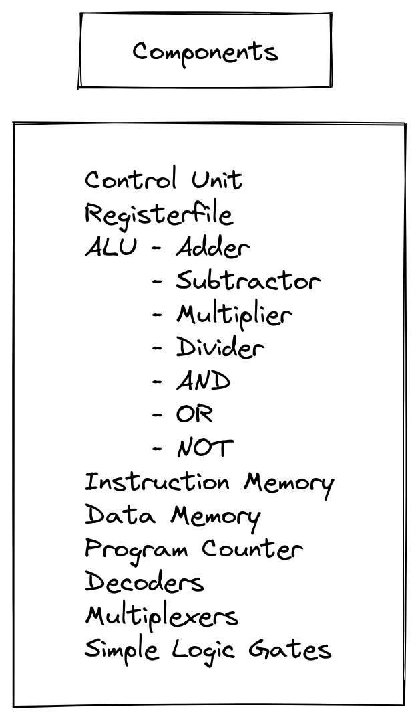

## 1.2. MEMORY AND ALU BUS SPECIFICATIONS

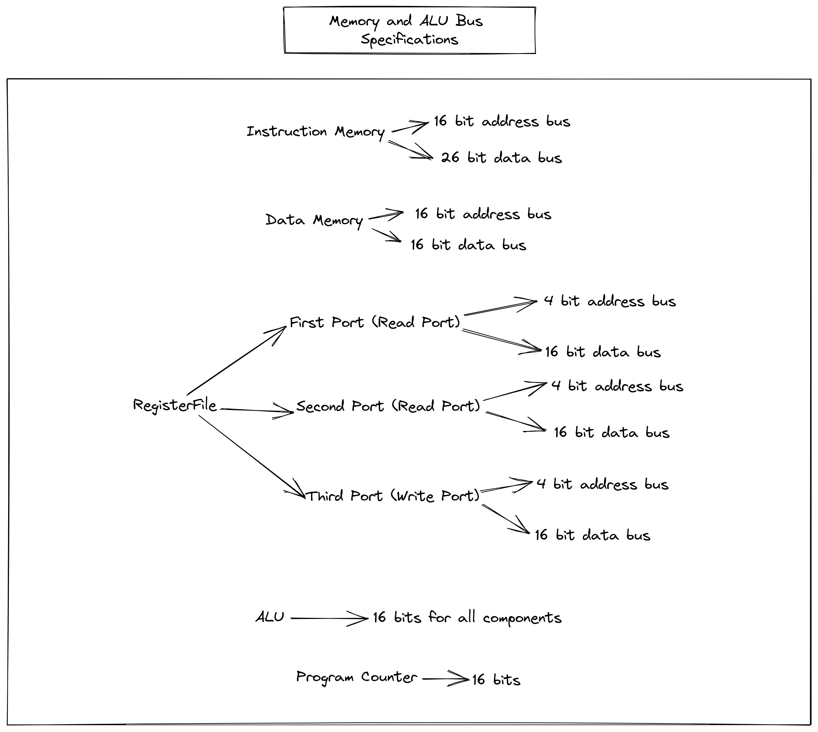

# THE ARCHITECTURE AND THE MICROARCHITECTURE

## 2.1. INSTRUCTION CATEGORIES

## 

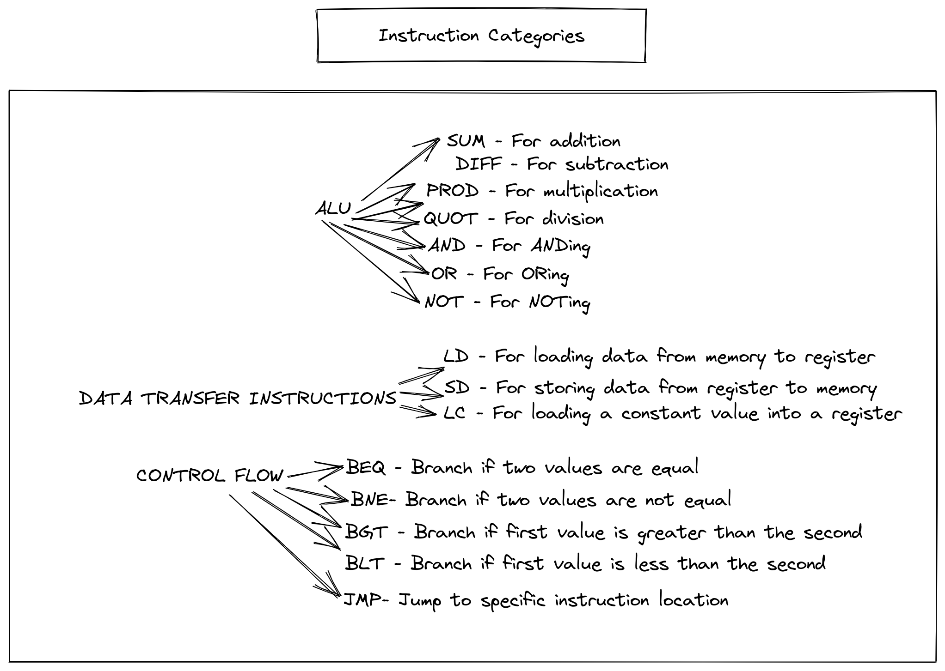

## 2.2. INSTRUCTION TYPES

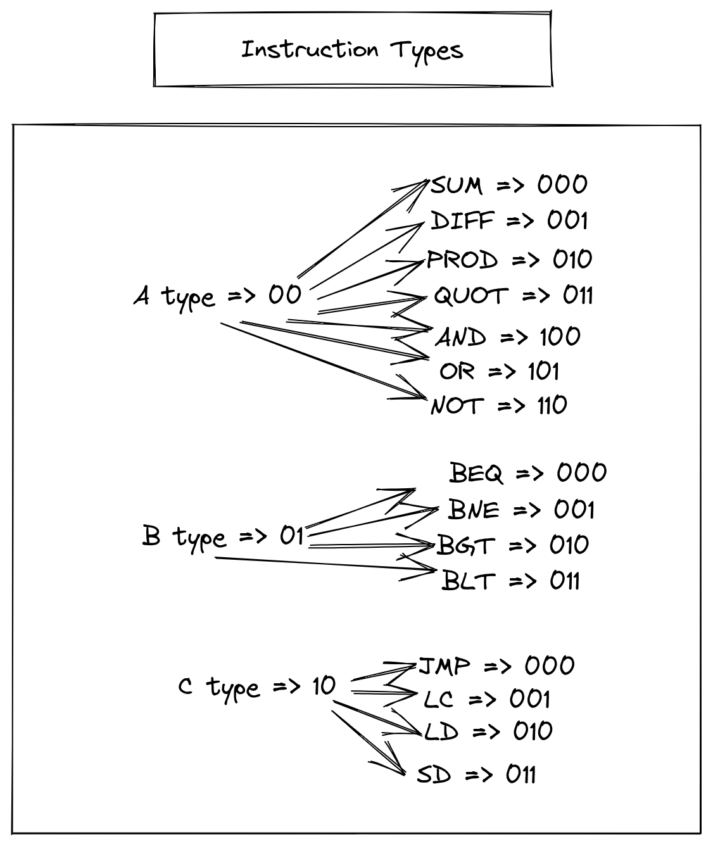

## 2.4. MEMORY LABELS

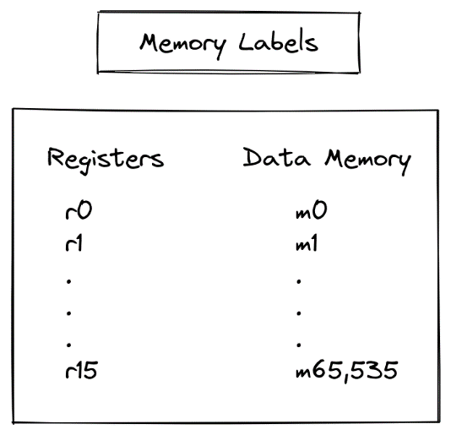

## 2.5. A TYPE INSTRUCTIONS

### 2.5.1. INSTRUCTION FORMAT

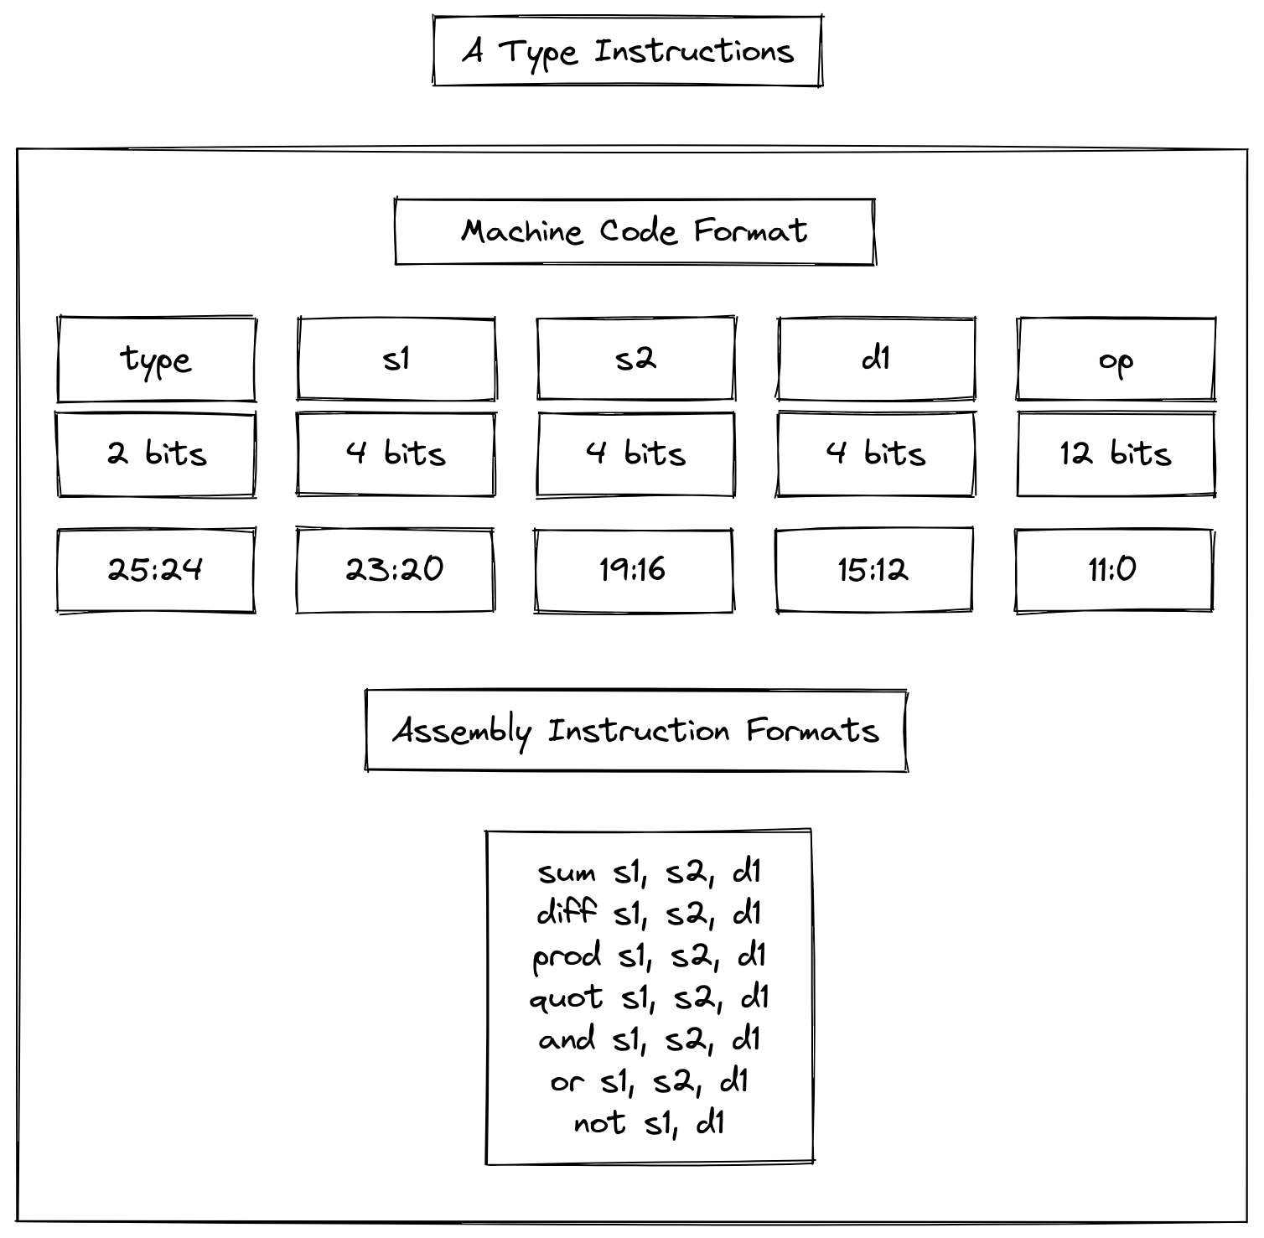

### 2.5.2. DATAPATHS

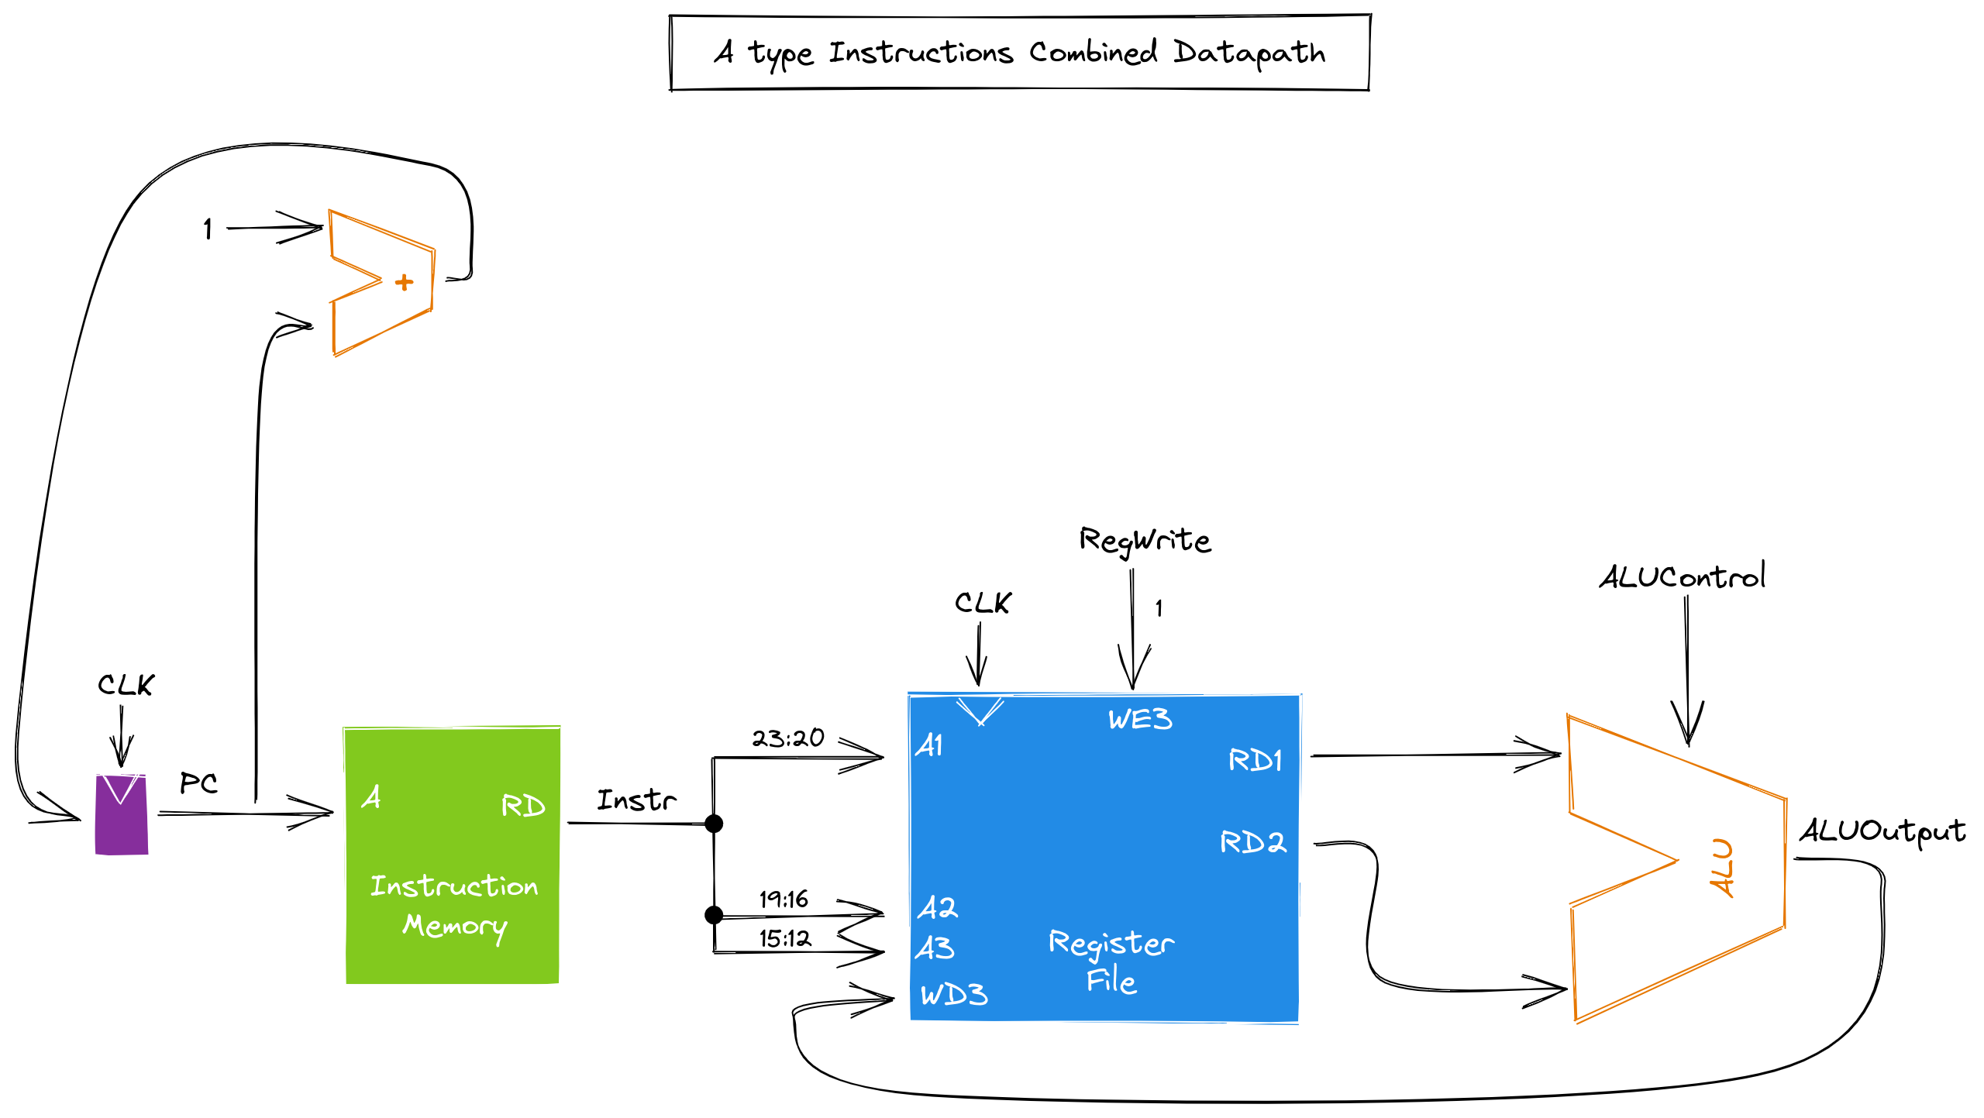

### 2.5.3. TRUTH TABLE

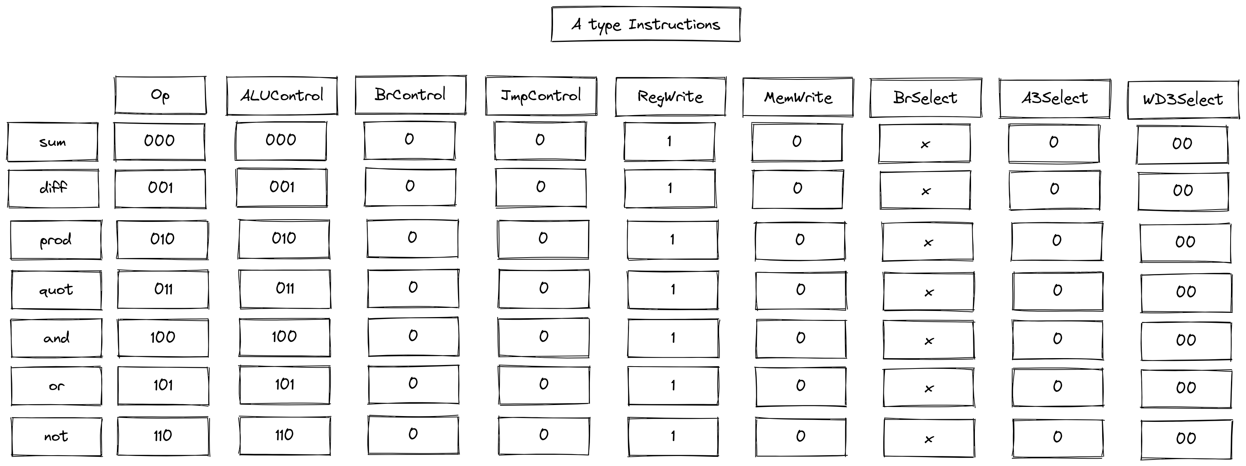

## 2.6. B TYPE INSTRUCTIONS

### 2.6.1. INSTRUCTION FORMAT

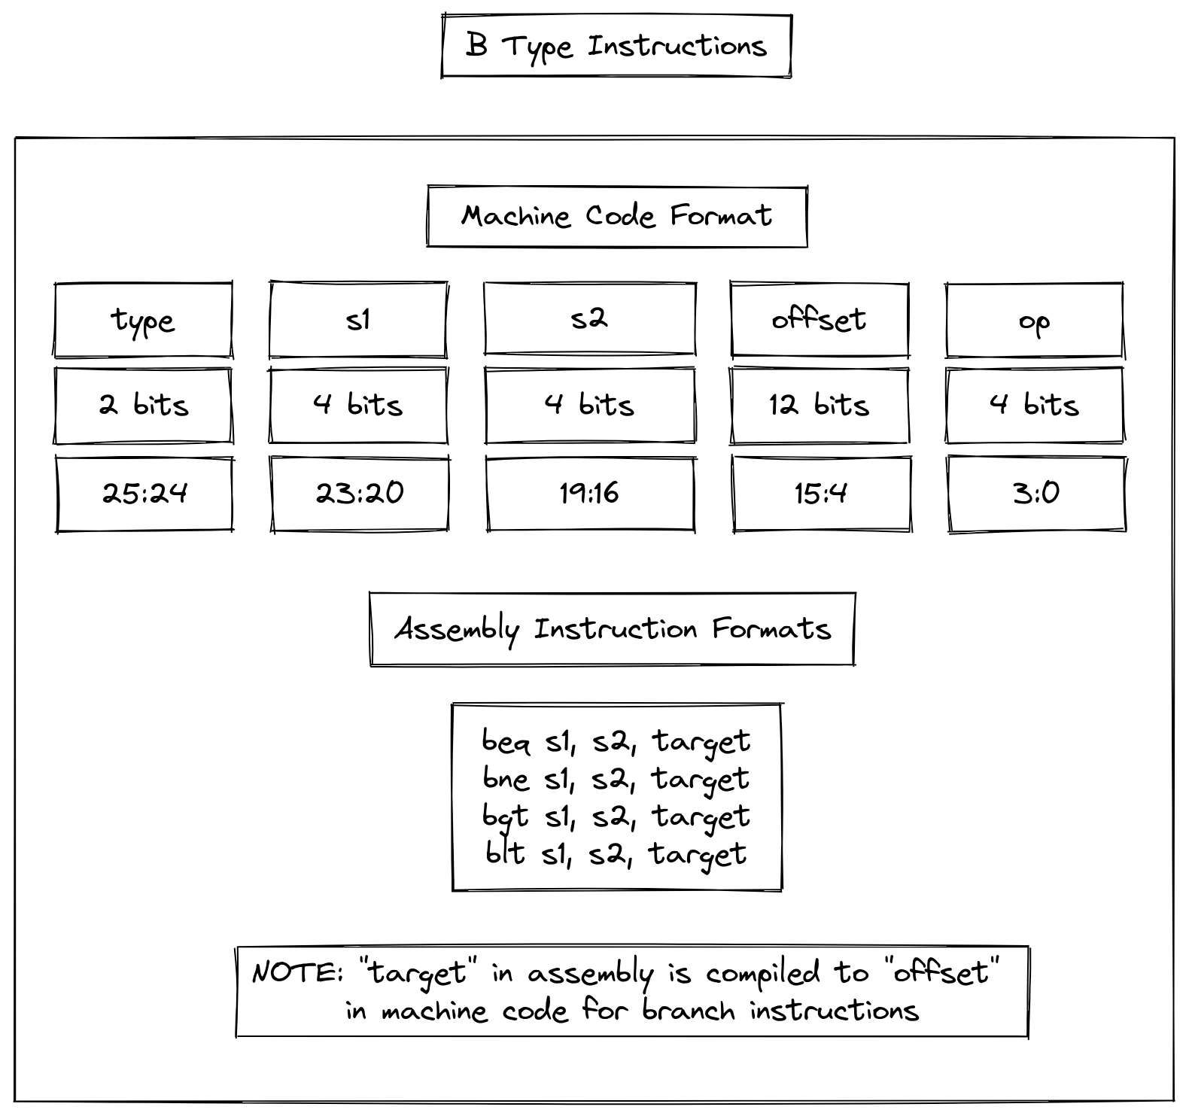

### 2.6.2. DATAPATHS

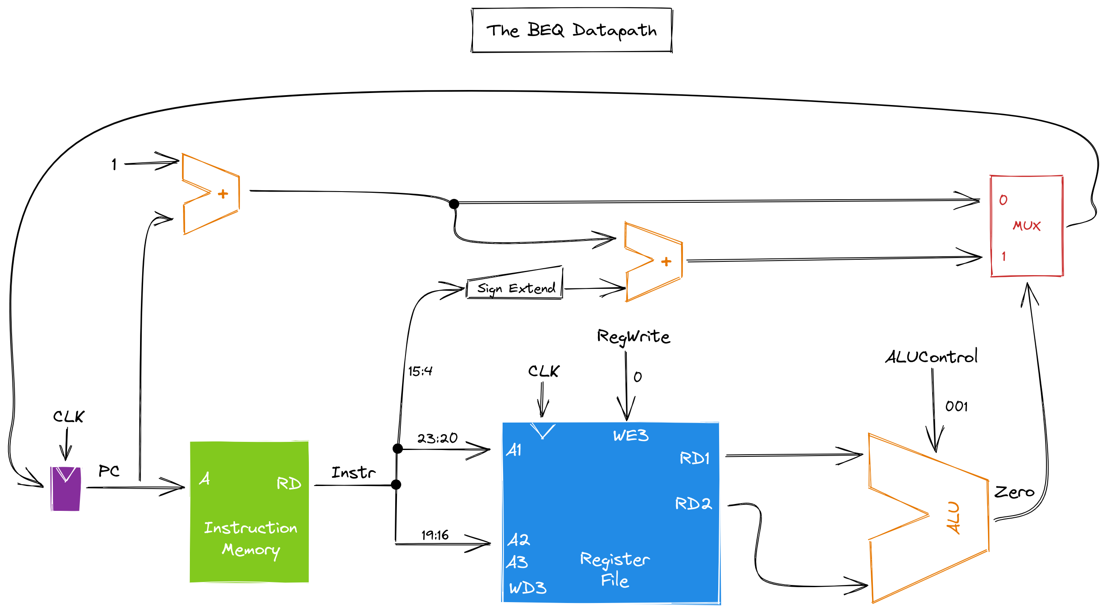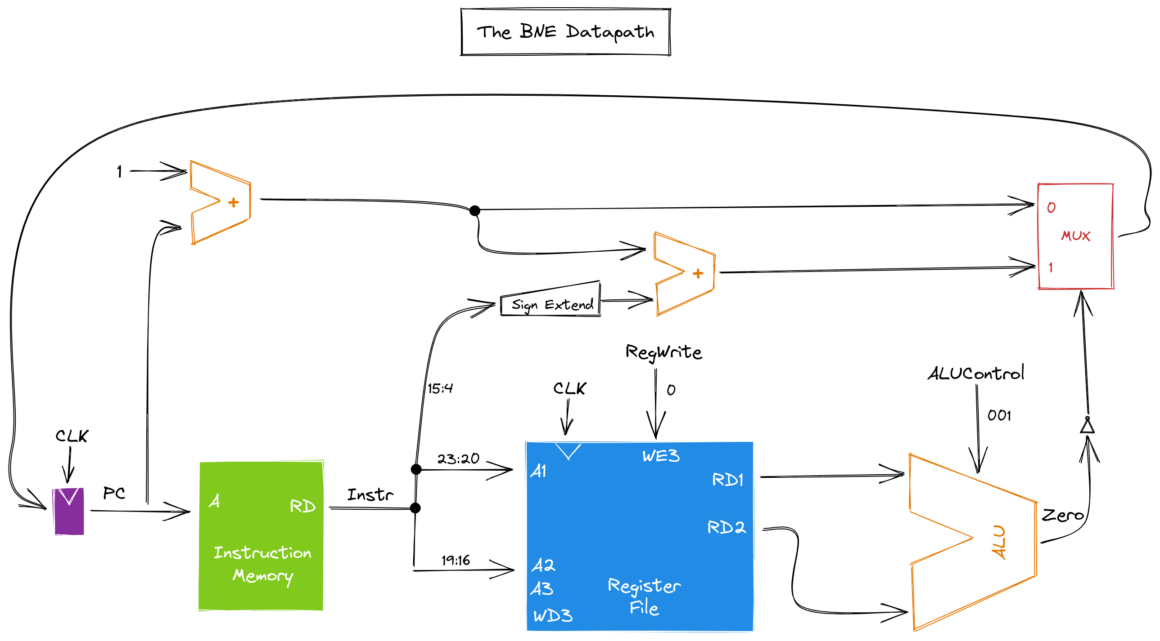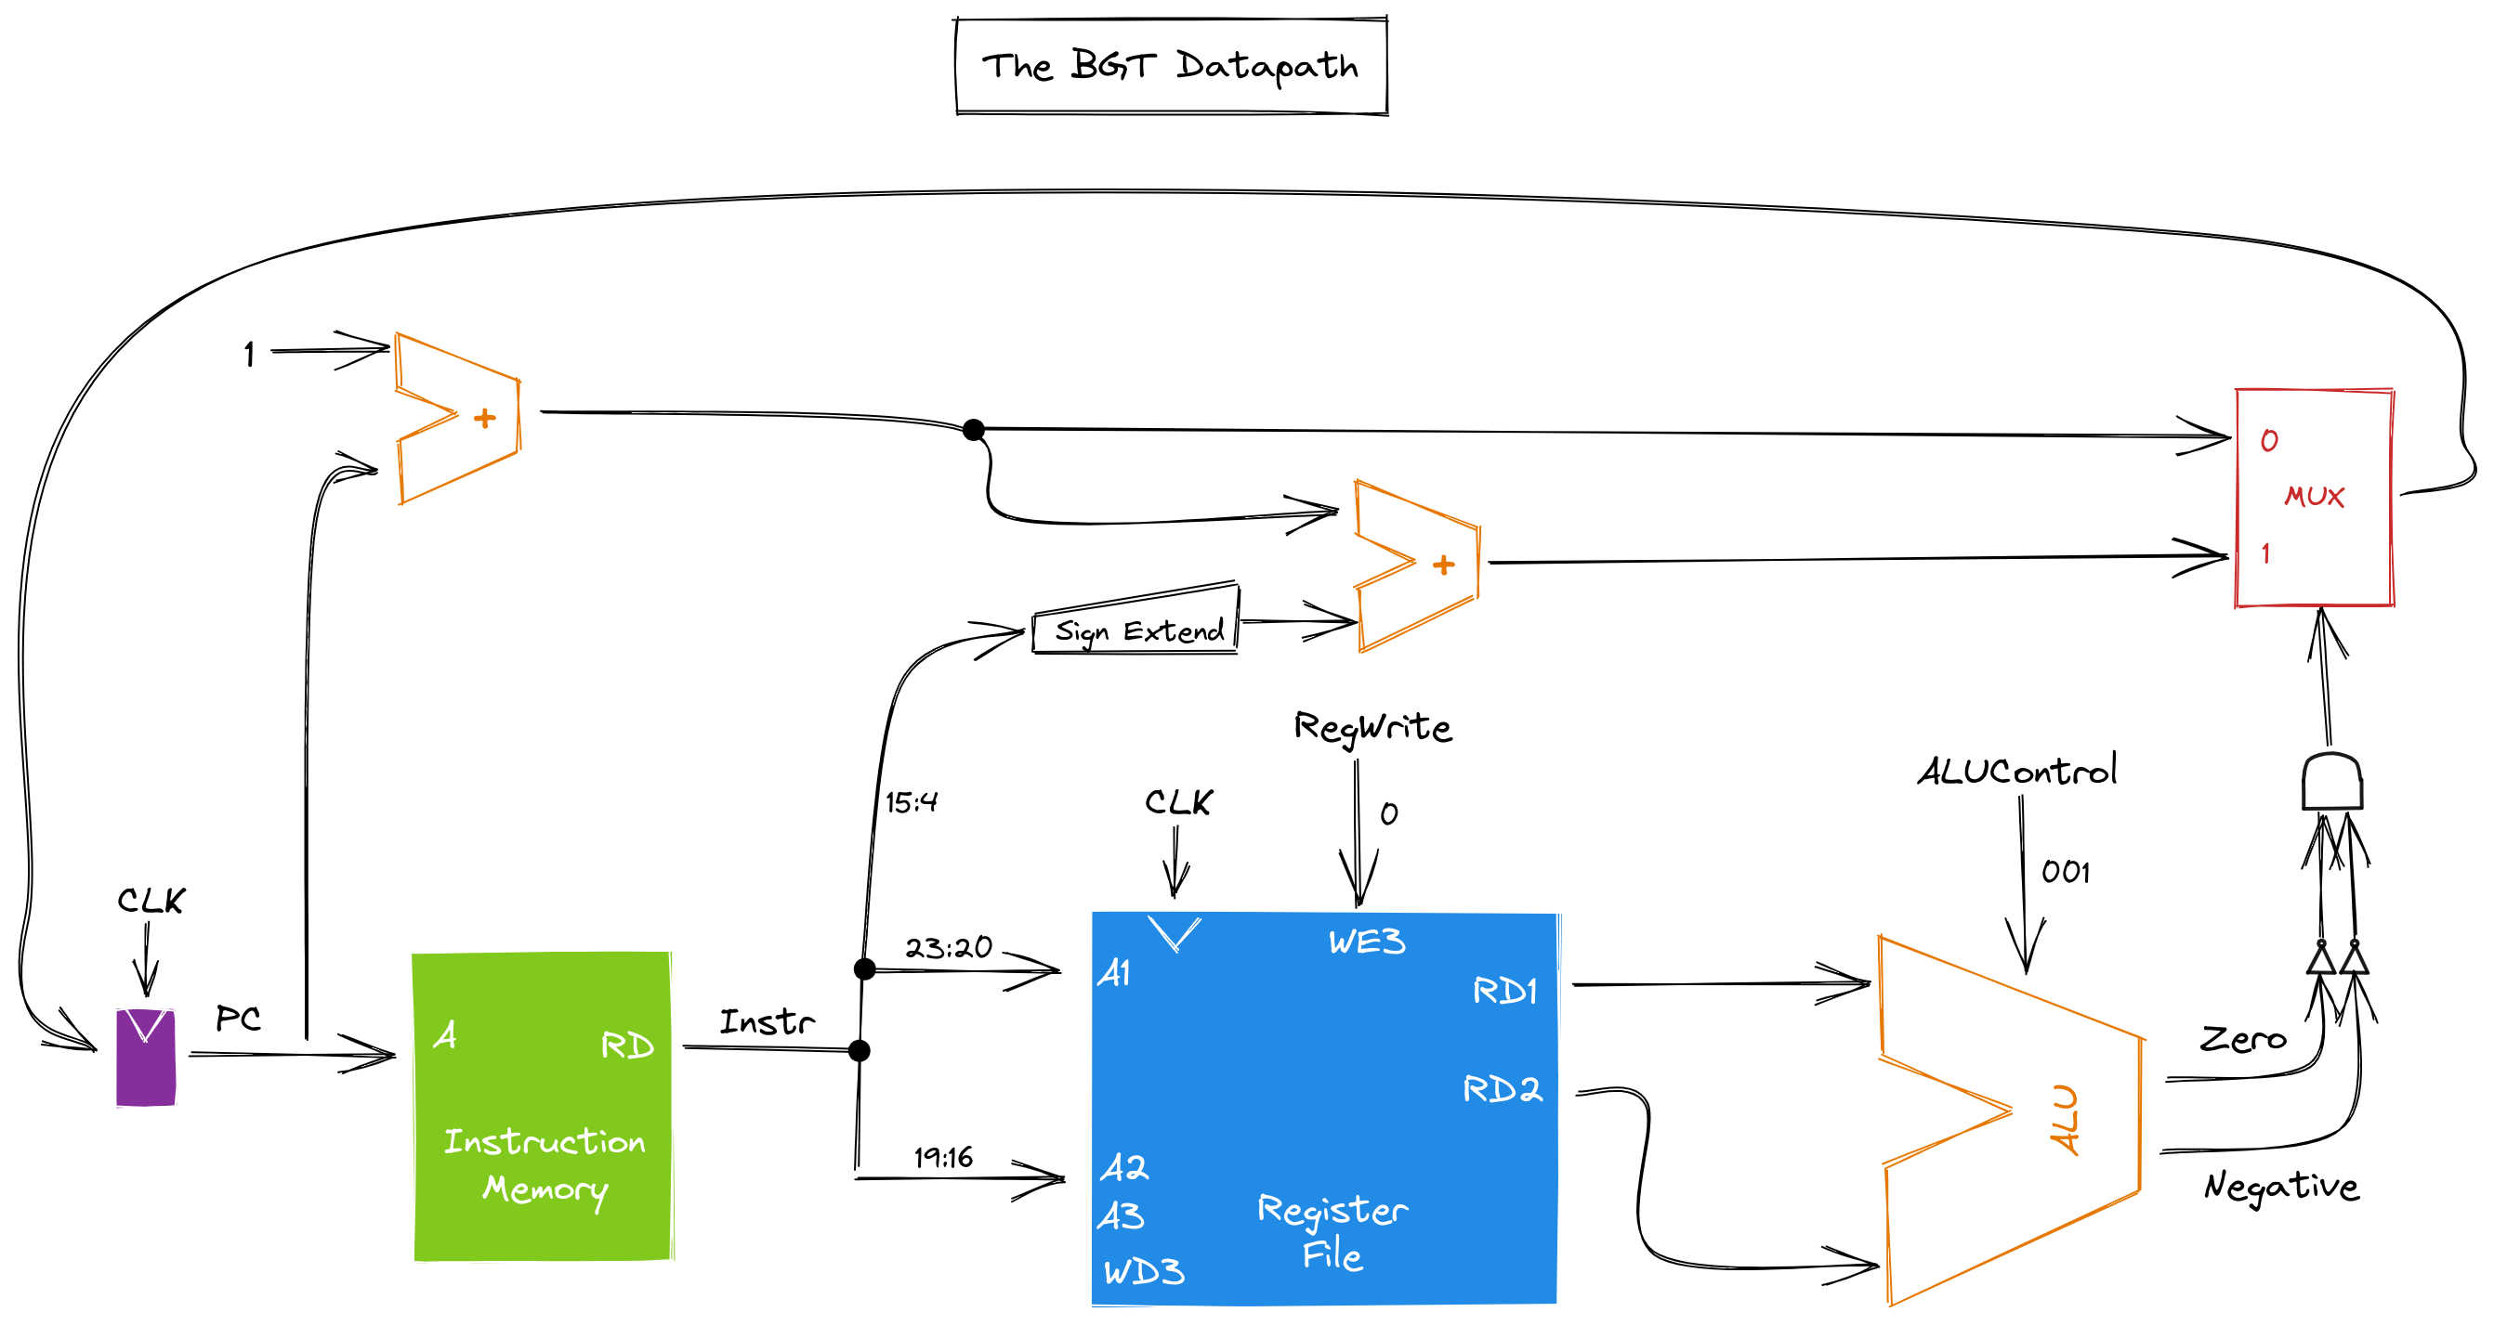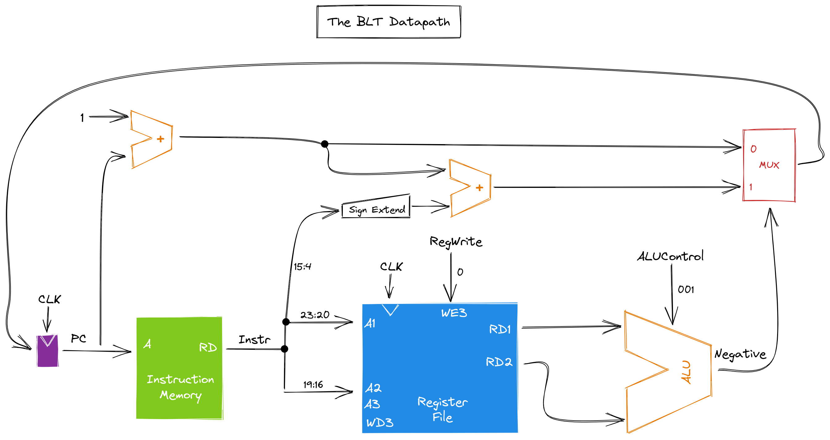

### 2.6.3. TRUTH TABLE

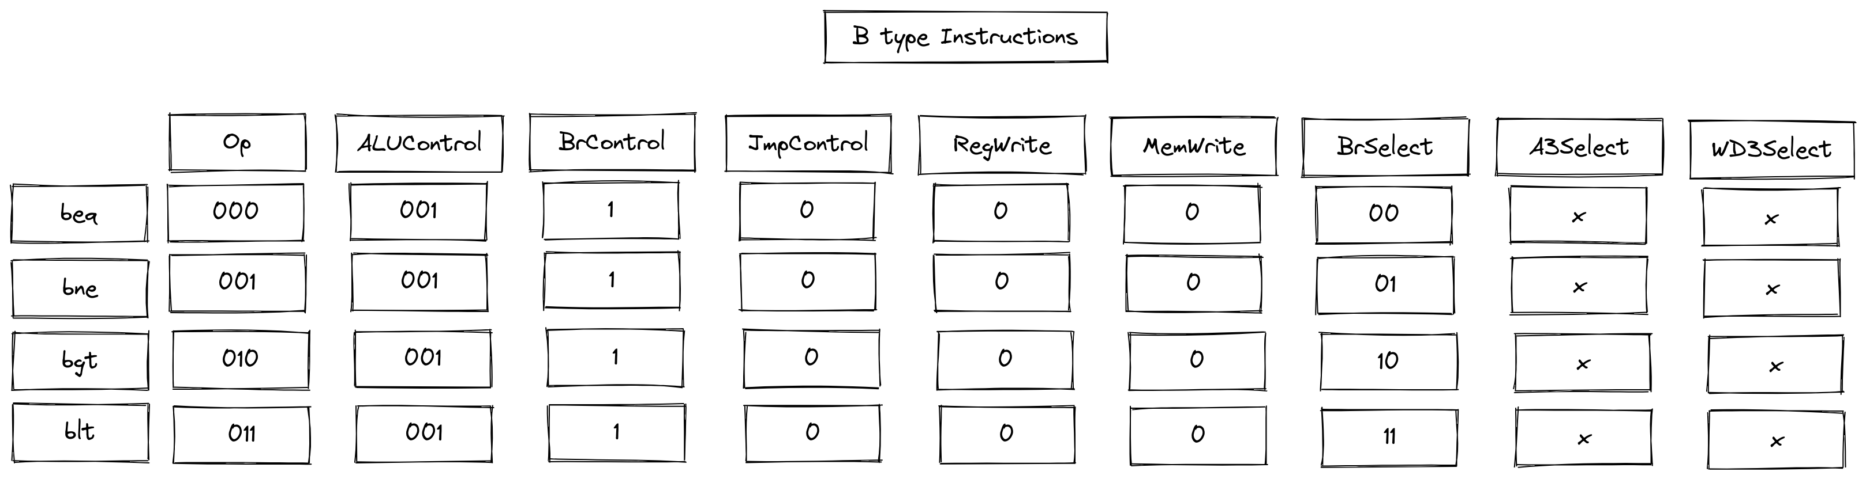

## 2.7. C TYPE INSTRUCTIONS

### 2.7.1. INSTRUCTION FORMAT

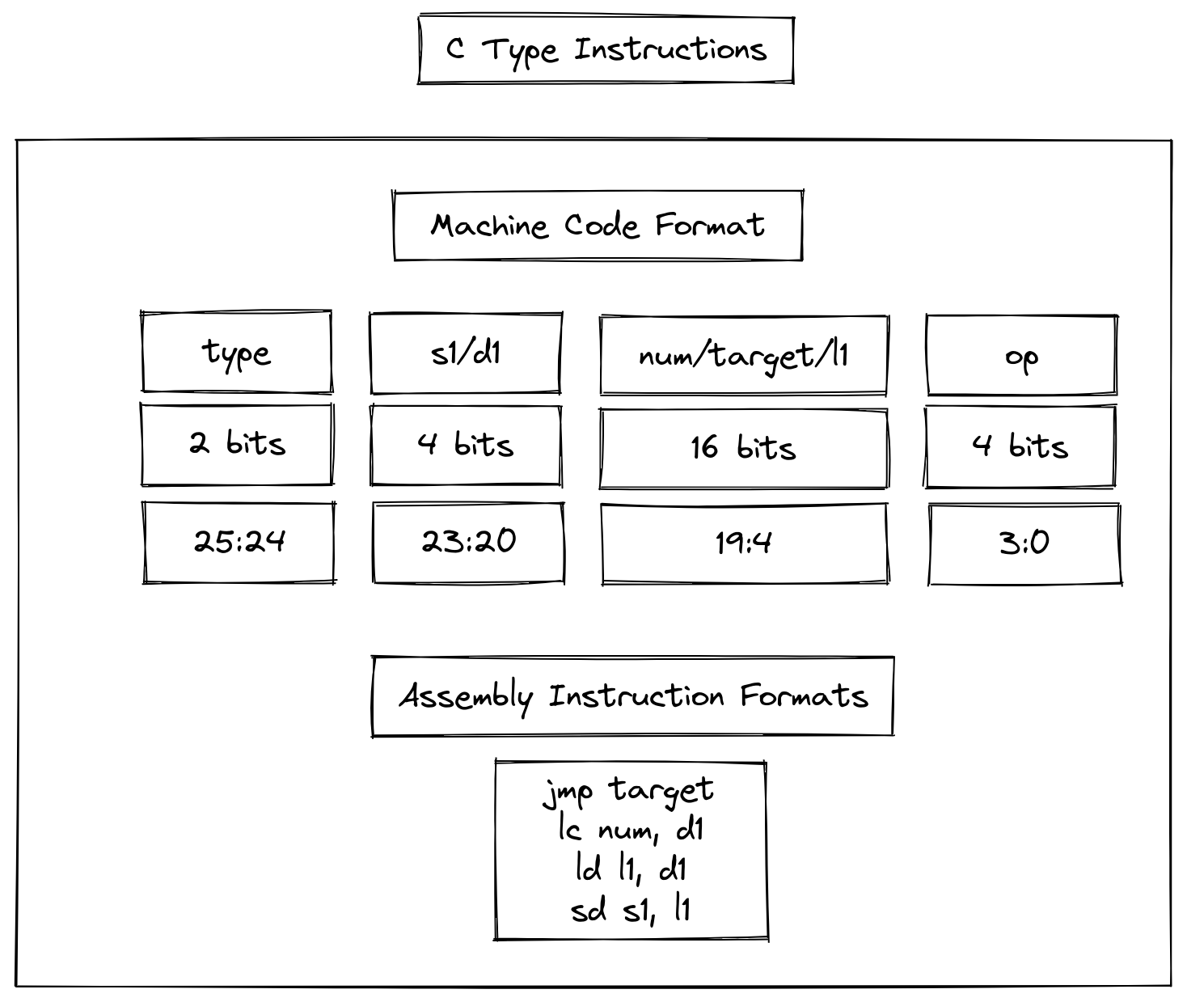

### 2.7.2. DATAPATHS

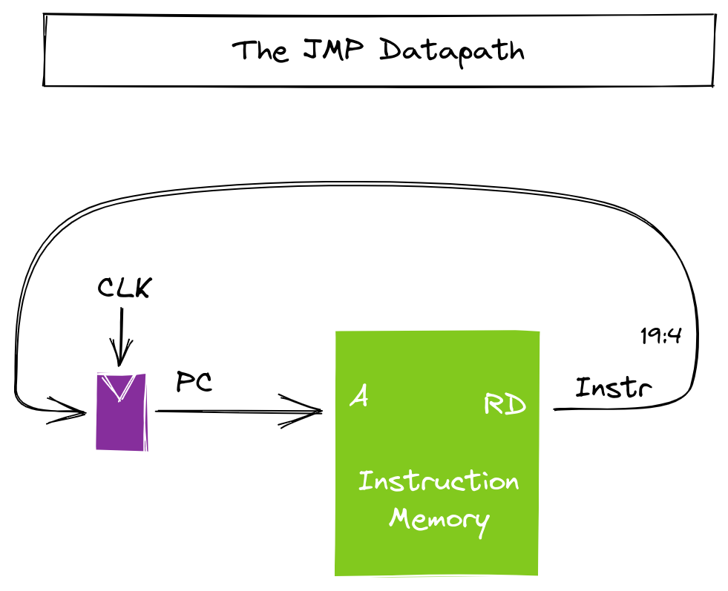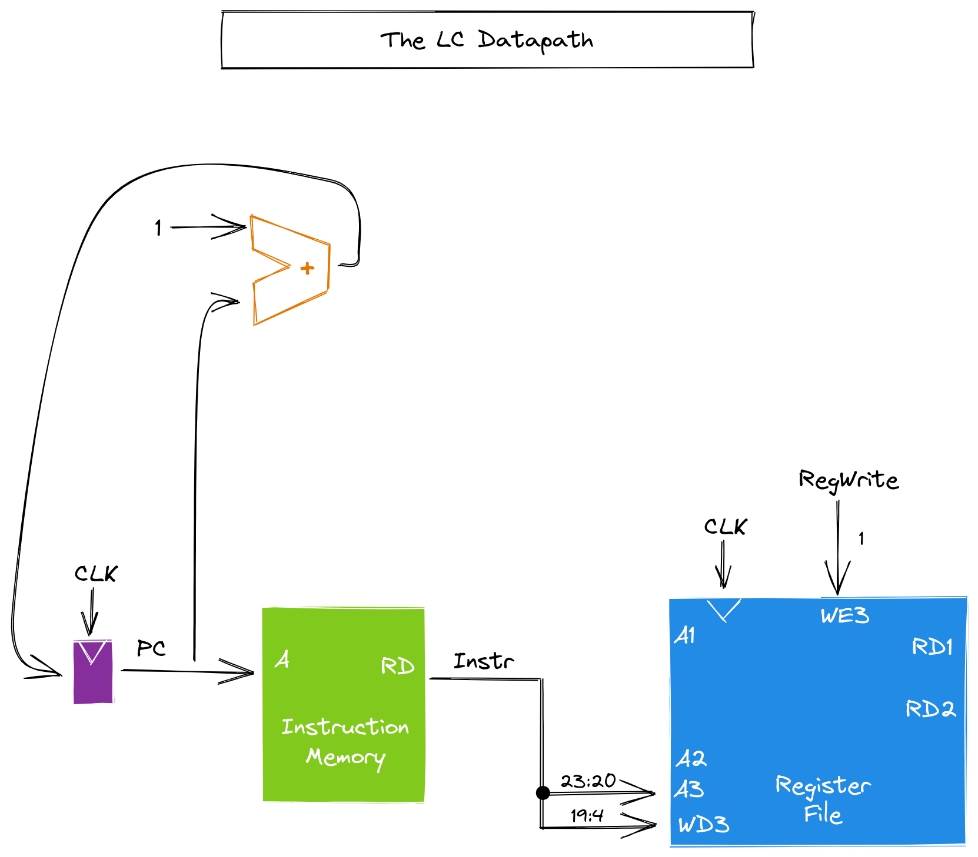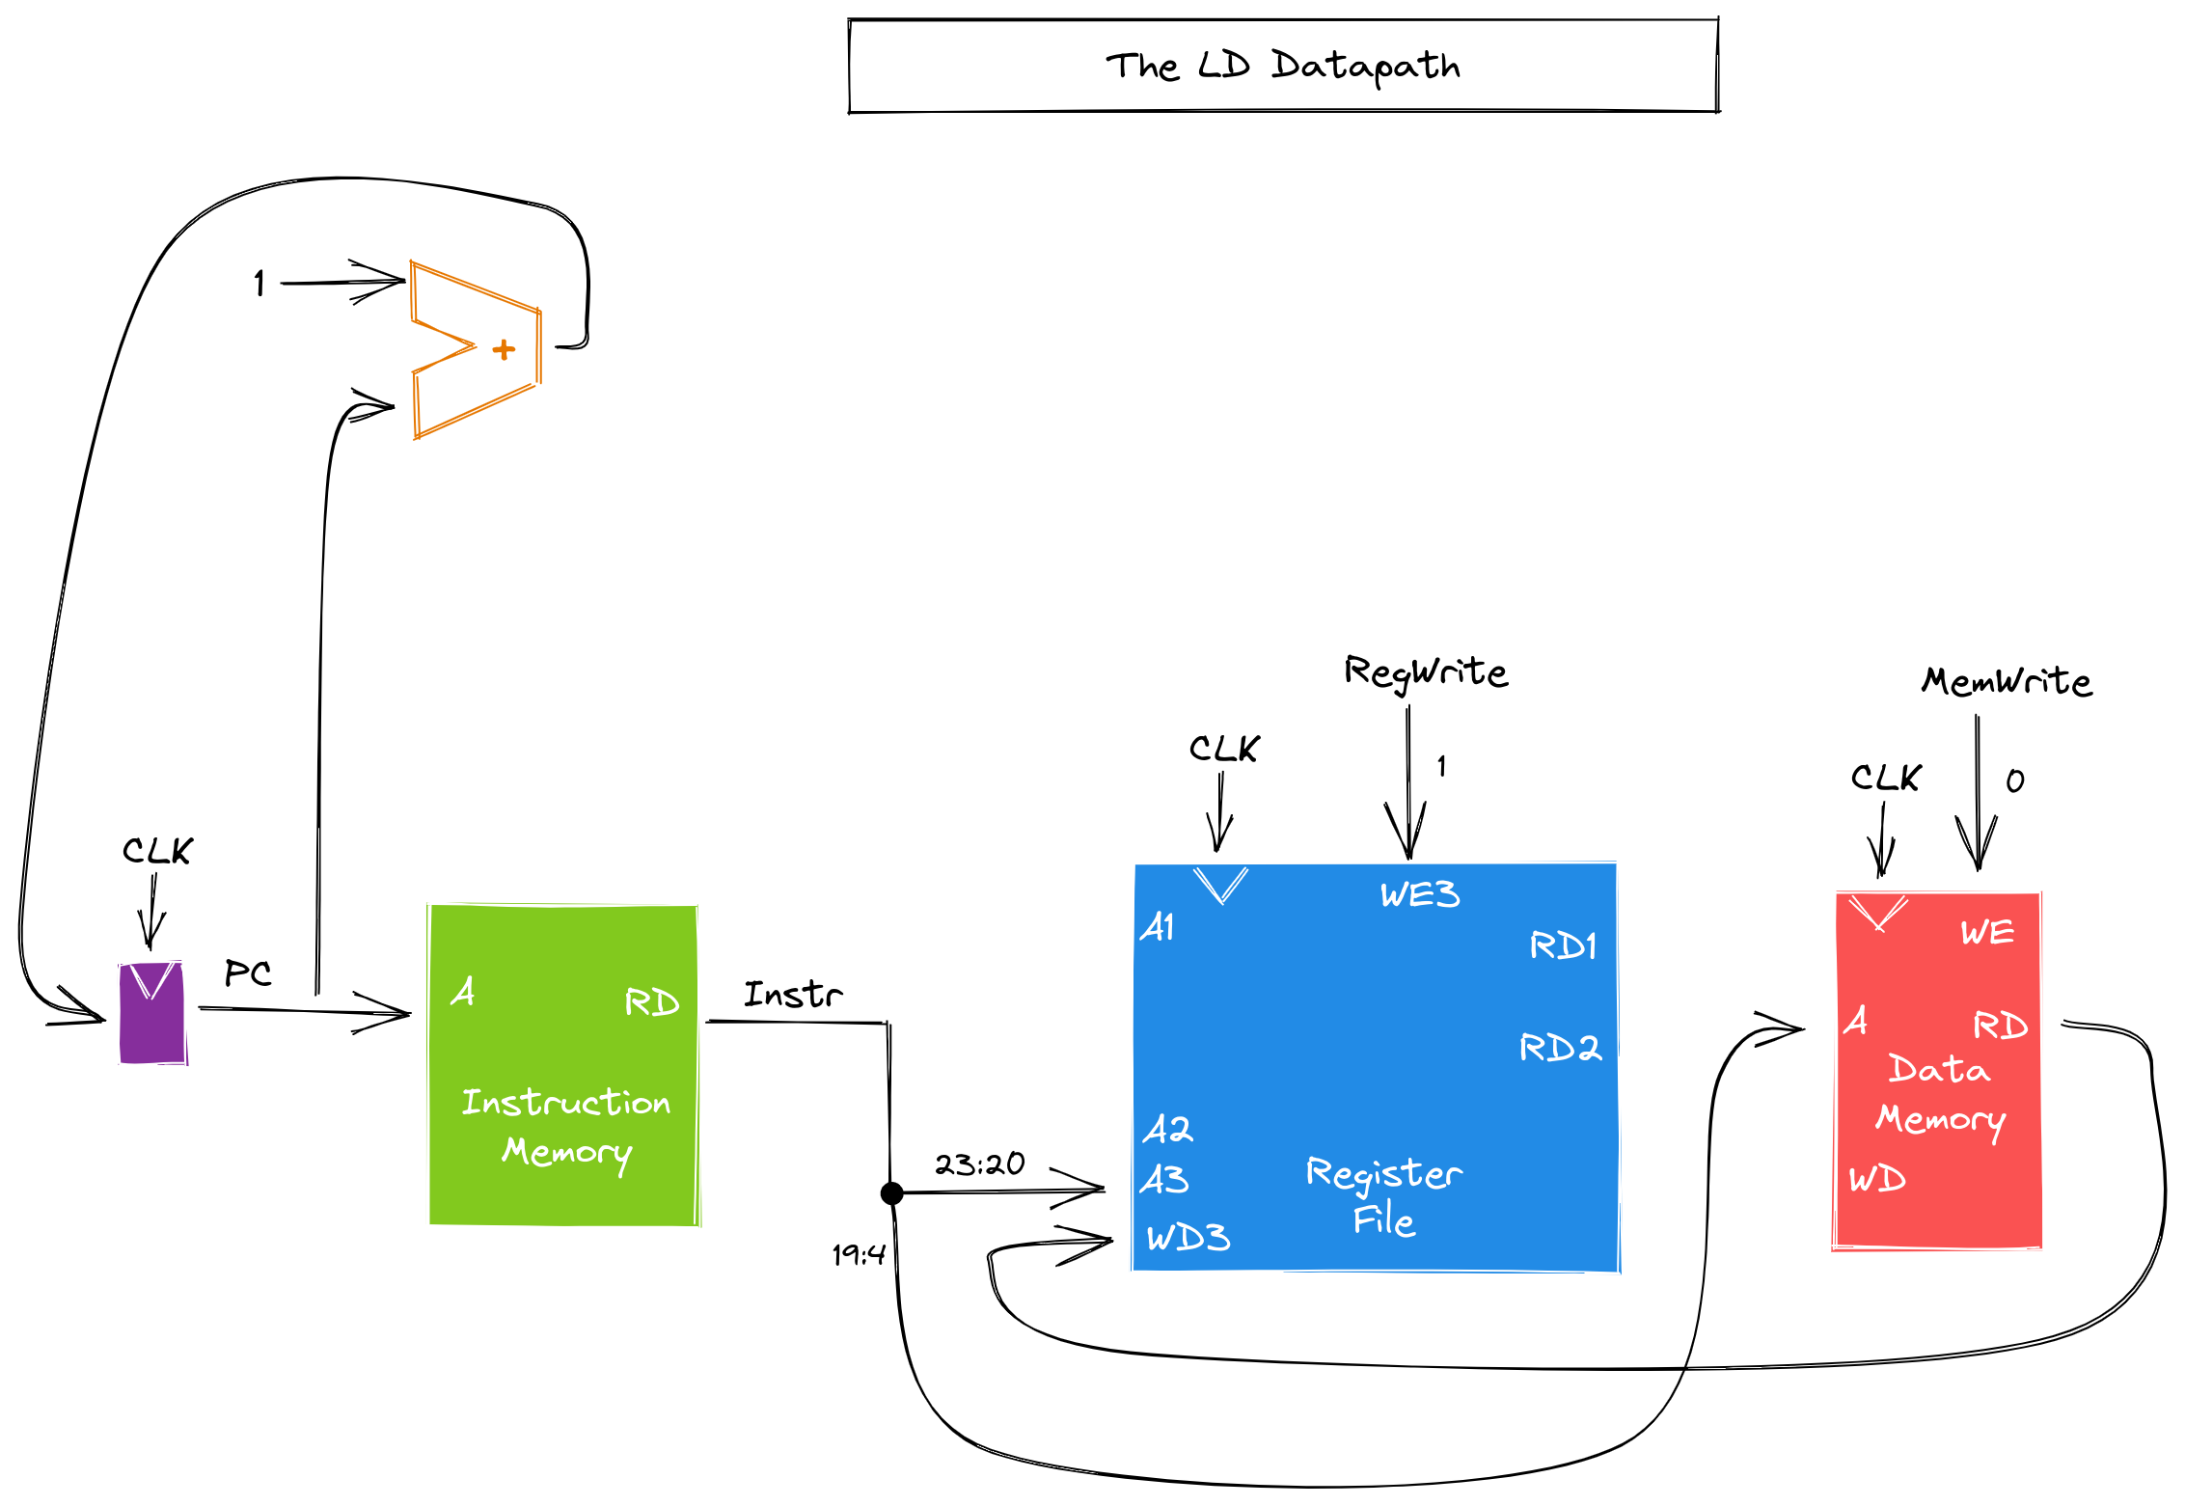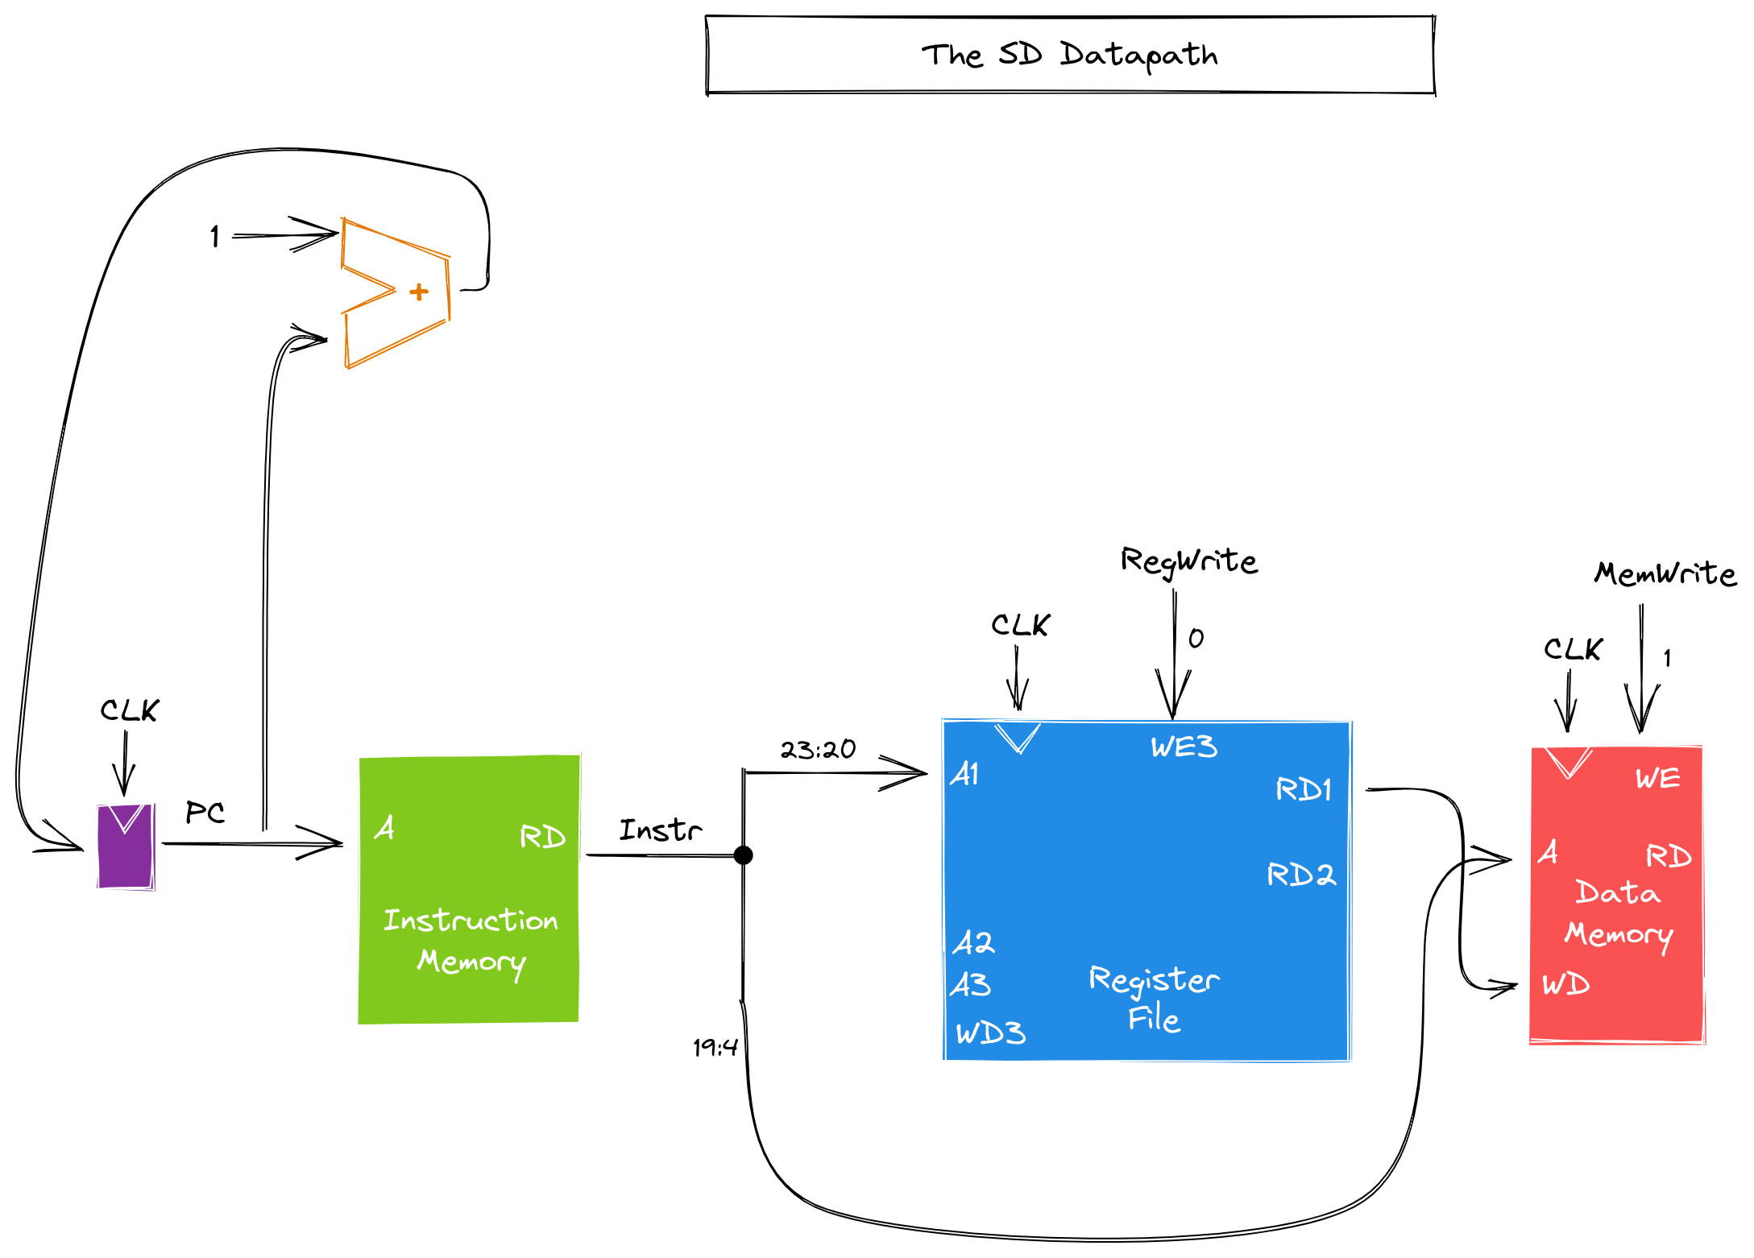

### C:\Users\user\AppData\Local\Microsoft\Windows\INetCache\Content.Word\c-type-combined-datapath.png

### 2.7.3. TRUTH TABLE

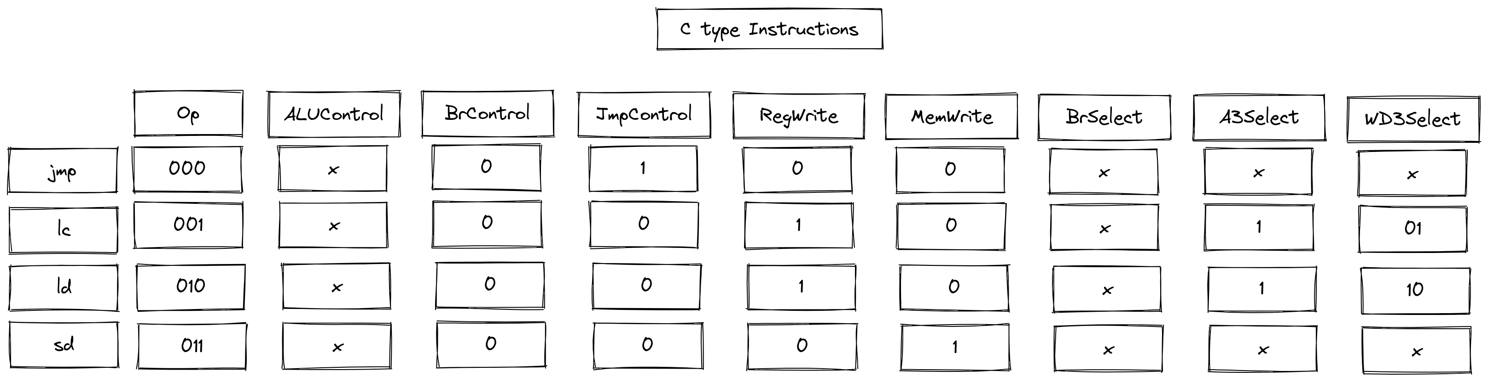

## 2.8. COMBINED DATAPATHS

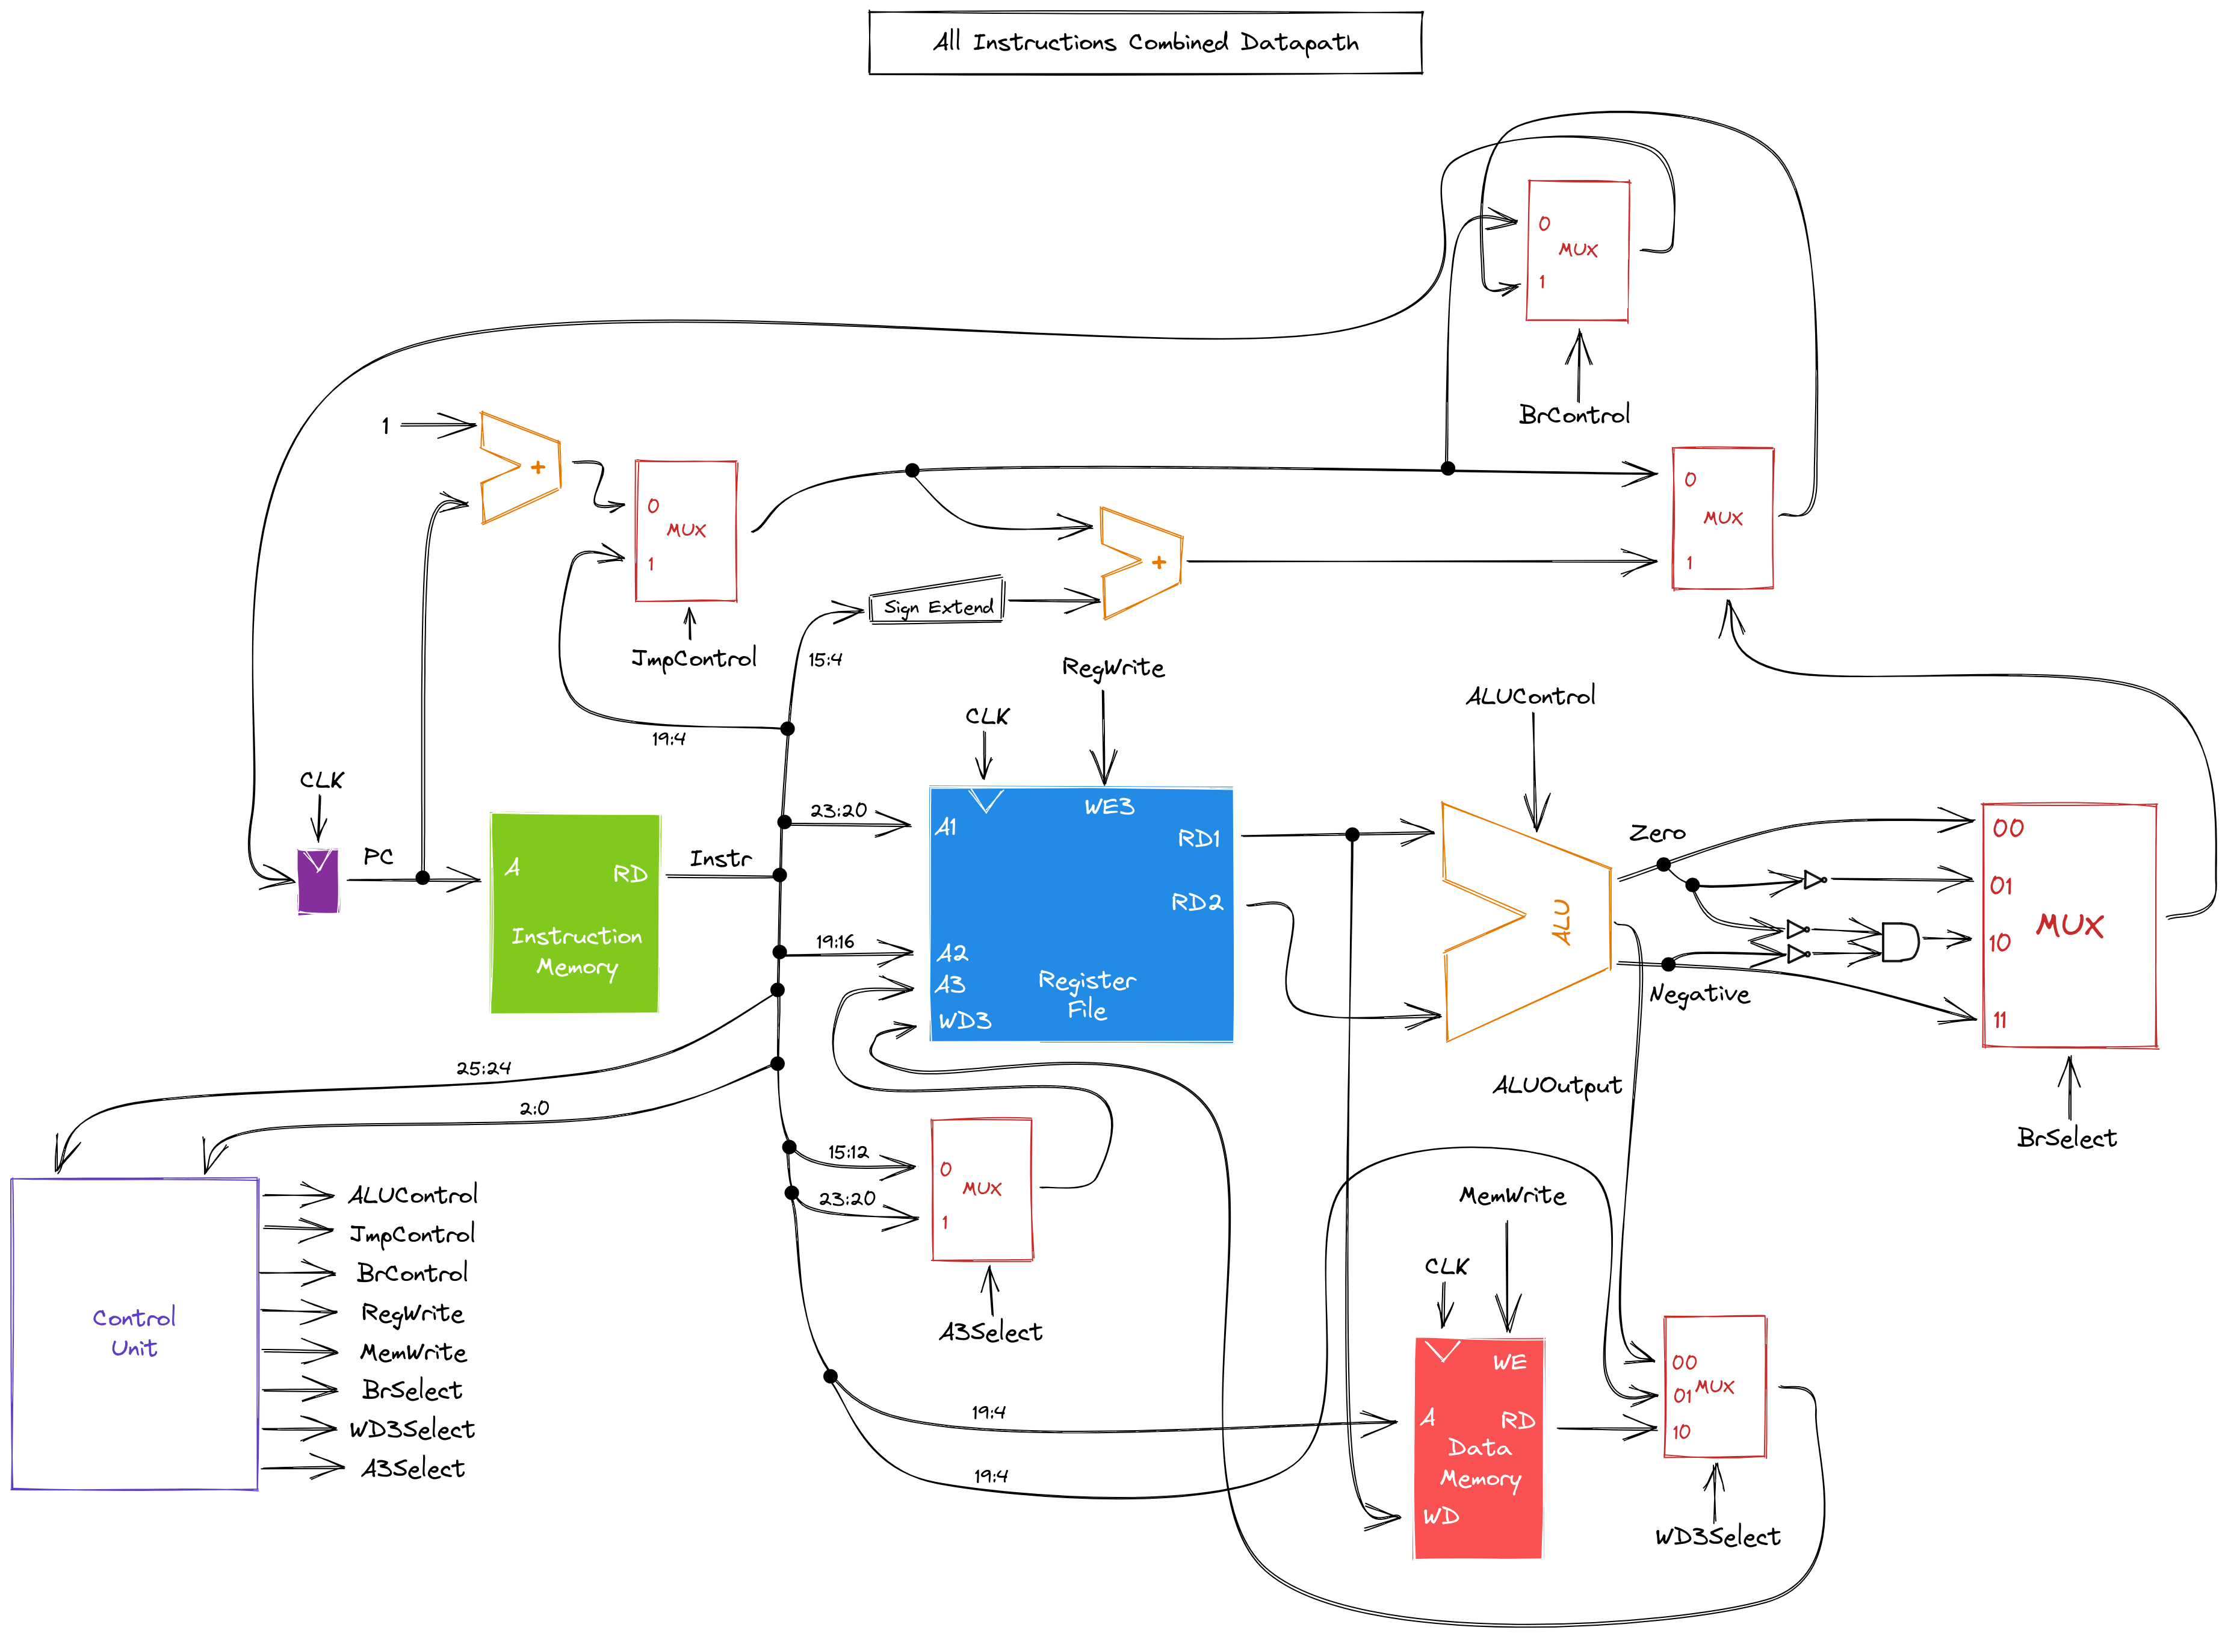

## 2.9. COMPONENTS BUILT IN LOGISIM

### 2.7.1. REGISTERFILE

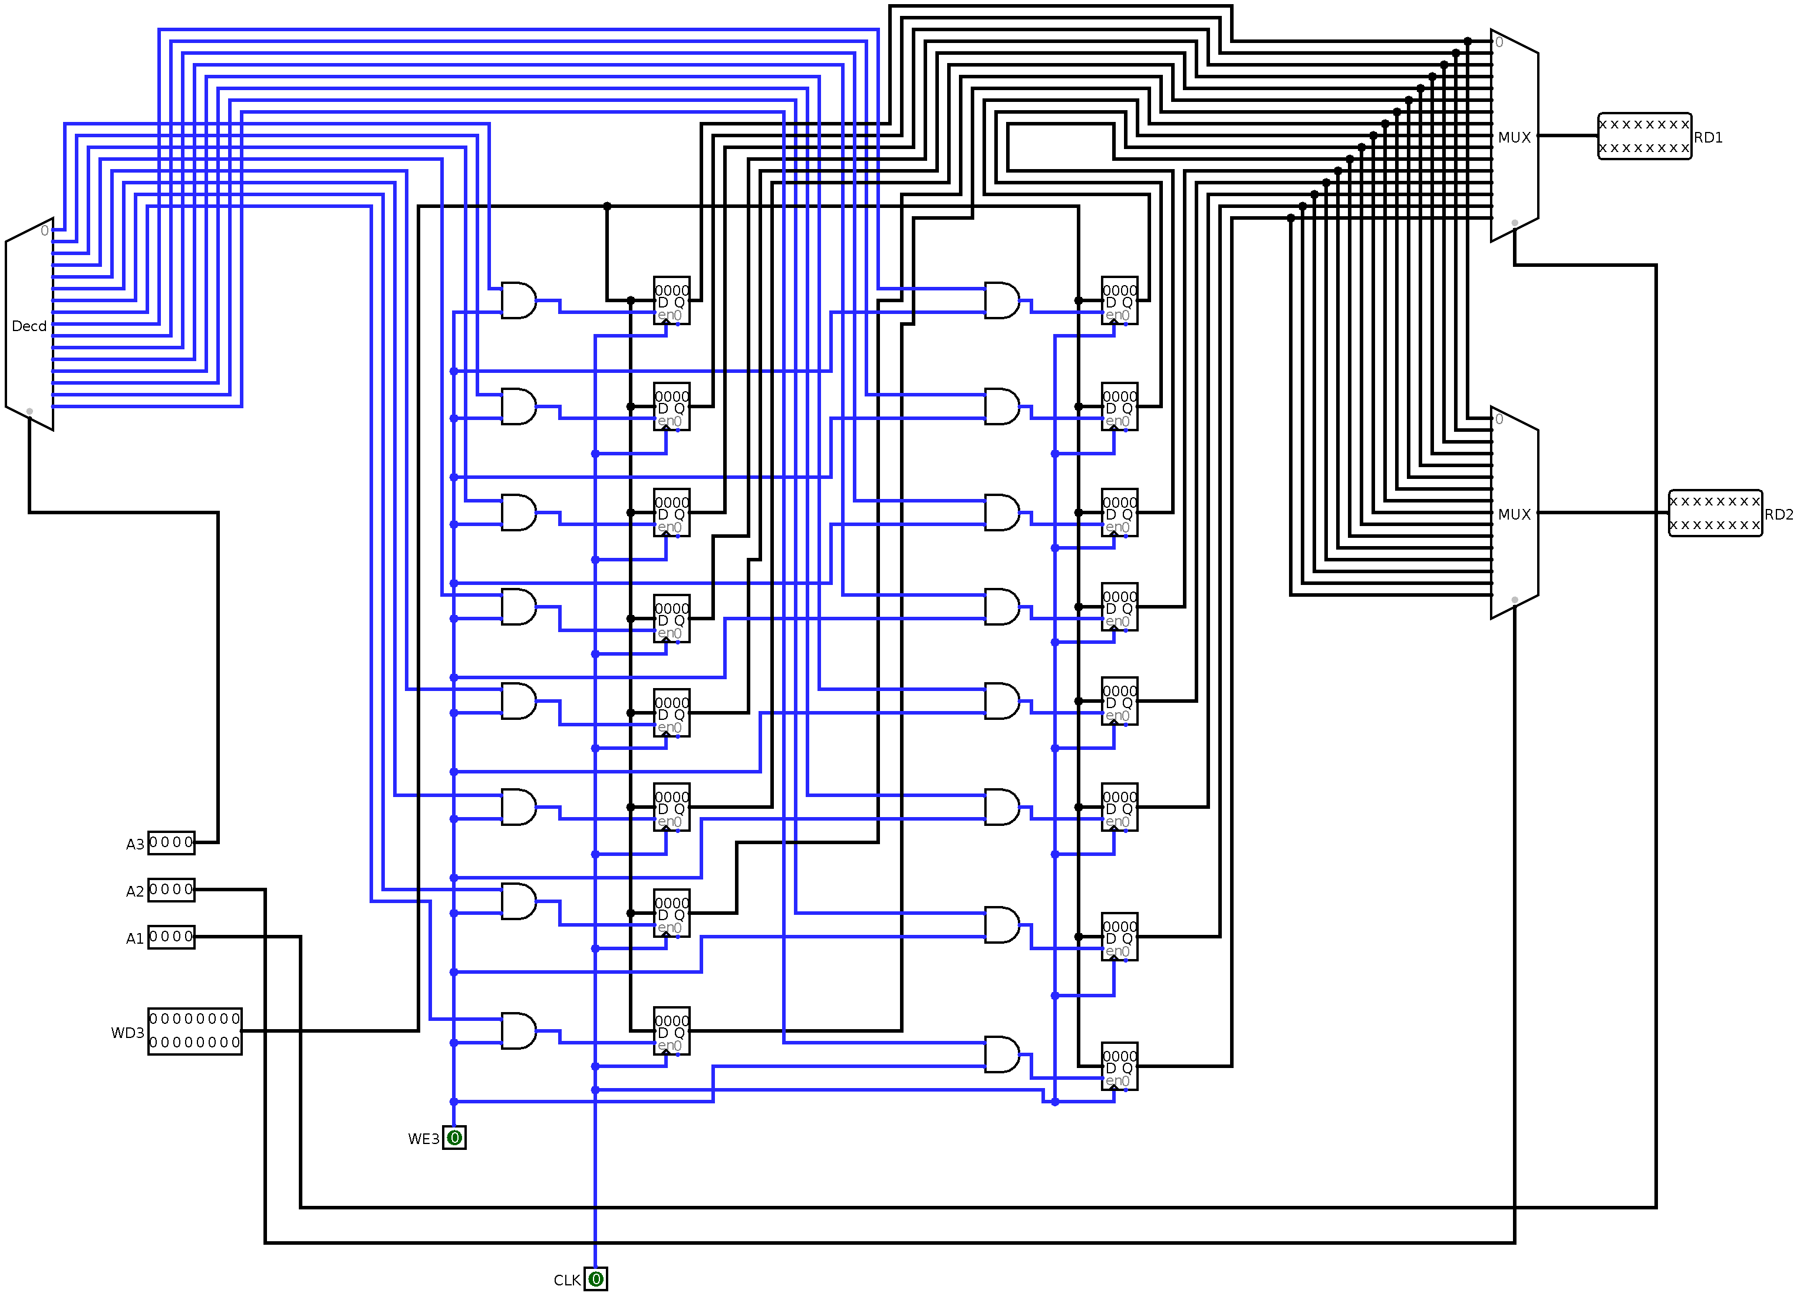

### 2.7.2. ALU

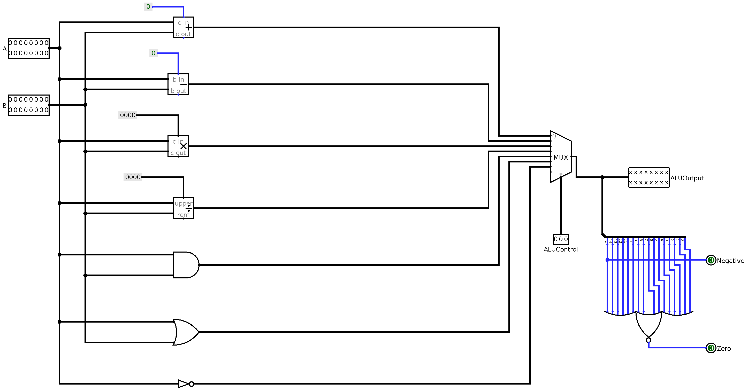

### 2.7.3. A TYPE CONTROL UNIT

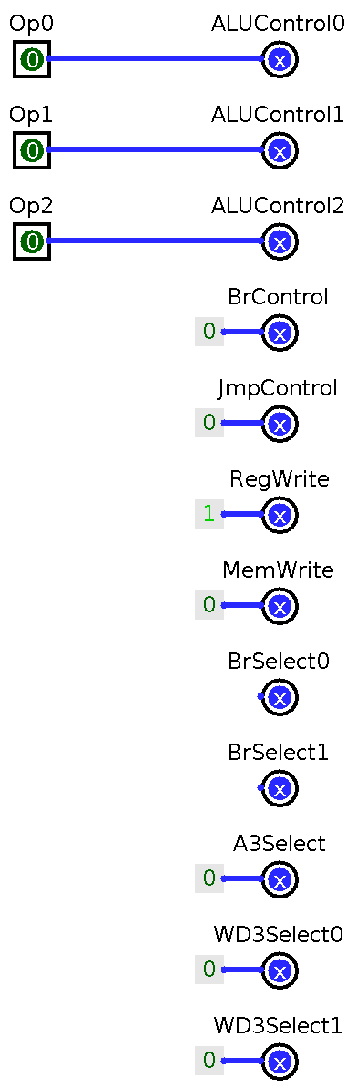

### 2.7.4. B TYPE CONTROL UNIT

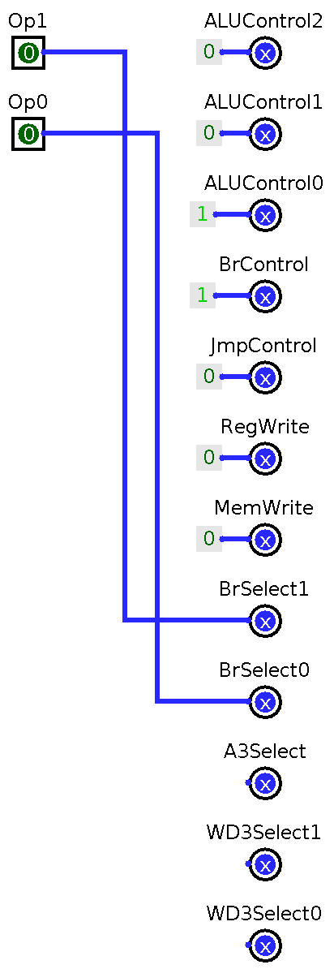

### 2.7.5. C TYPE CONTROL UNIT

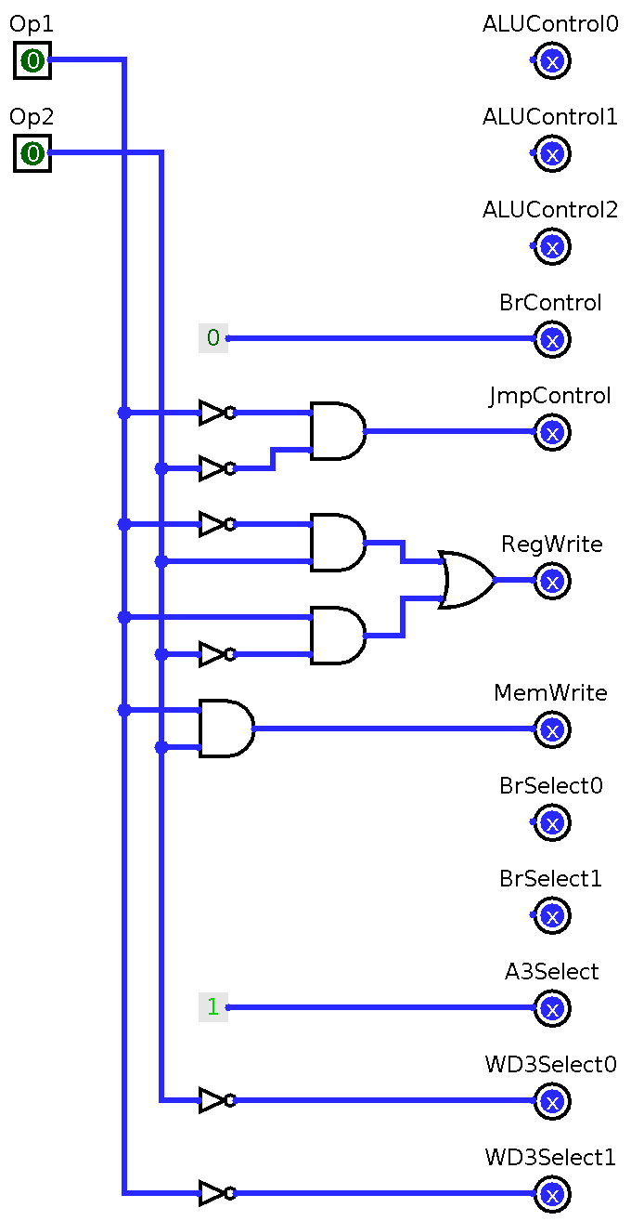

### 2.7.6. COMBINED CONTROL UNIT

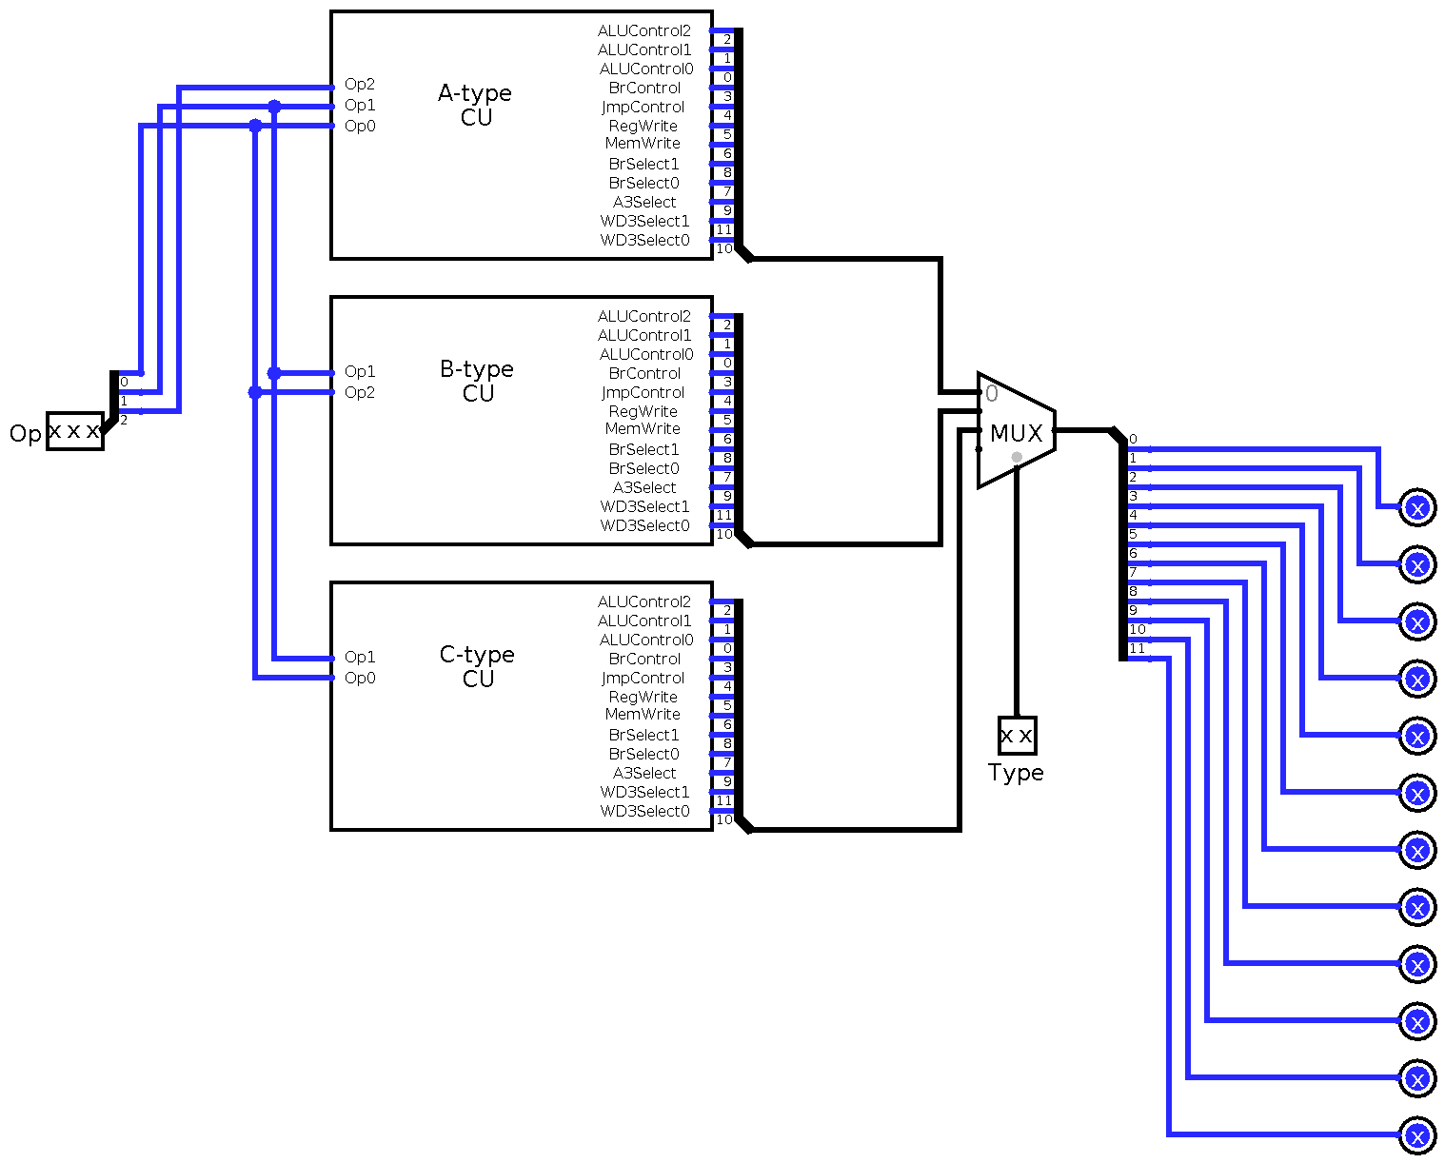

### 2.7.7. COMPLETE MICROPROCESSOR CIRCUIT

